# CS 255 System Design Document Template

Abdulrahman Al-Nachar

CS255 - Project Two

## UML Diagrams

### UML Use Case Diagram

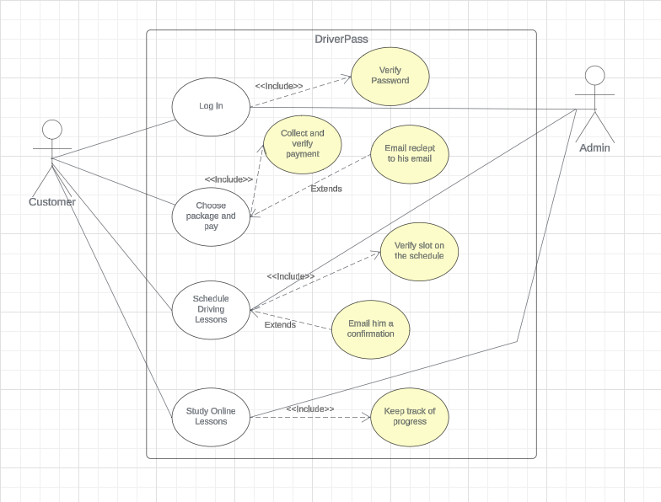

### UML Activity Diagrams

### UML Sequence Diagram

Login UML Sequence Diagram.

### UML Class Diagram

## Technical Requirements

**Hardware Requirements:**

1. Reliable Internet on the user’s end.
2. Modern devices to access web application.
3. Enough storage to store the necessary data attached to the application.

**Software Requirements:**

1. Know Front-end coding languages like (HTML, CSS, Javascript).
2. Know Back-end coding languages.
3. Make sure that the system can work on all OS and platforms.

**Tools & Infrastructure Requirements:**

1. An IDE to code the program.
2. Cloud Infrastructure to host the platform.
3. Security mechanisms like data encryption.
4. User authentication mechanisms to protect the platform and its users.